y vs x Graph
The problem you are currently viewing involves a y vs. x graph. Hence, all of the help below relate to that type of graph as well.

How do you determine the direction of the initial velocity? (when v₀ and a have different directions and v₀ is not zero)
Imagine watching a friend throw a ball to another friend as shown in the diagram below. Because of gravity, the ball doesn’t follow a straight line. In fact, if the drag from air can be ignored, then the ball follows a path that is shaped like a parabola. This parabolic path is called the ‘trajectory’ of the ball.

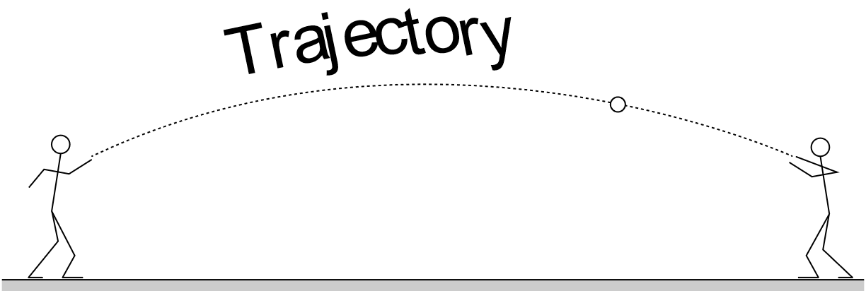

Now compare the trajectory in the diagram above to the y vs x graph for the same ball that is shown below.

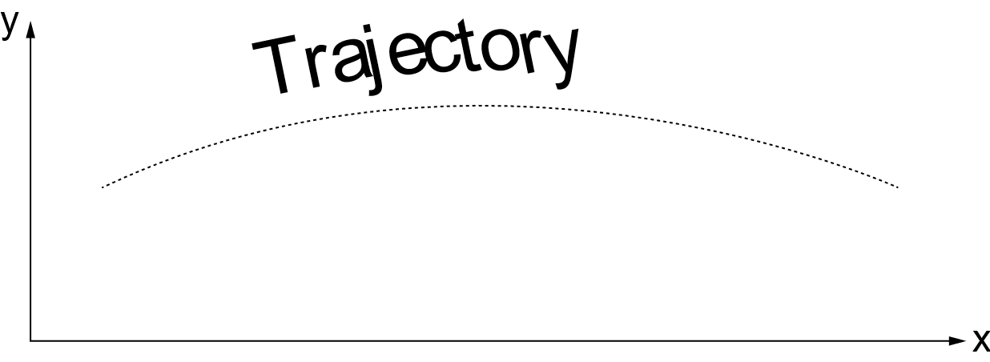

They appear to be identical because they are. Both represent a plot of the vertical coordinate y vs the horizontal coordinate x of the ball. In short, a y vs x graph of a motion is identical to the trajectory in a photograph of that motion.

The diagram below is identical to the one above, but this time, the ball is shown at five different instants as it moves along its trajectory. A velocity vector has also been drawn at each of these five instants. The direction of these velocity vectors indicates the direction the ball is moving at each instant. In addition, notice that each of the velocity vectors is tangent to the trajectory.

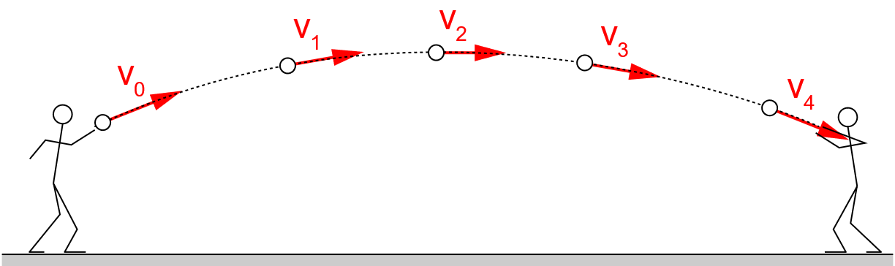

The reason you chose to read this blurb of text is to answer the question:
‘How do you determine the direction of the initial velocity?’

The initial velocity has the same direction as the vector that is tangent to the trajectory at the initial location of the ball! In the diagram above, the initial location is the instant the ball leaves the person’s hand. Hence, the vector labeled ‘v₀’ is the initial velocity. In the simulation, the initial location is indicated by the data point that has a black border and is slightly larger than the other data points. Hence, to determine the direction of the initial velocity, simply determine the direction that is tangent to the trajectory at that point.

How do you determine the direction of the initial velocity? (when the trajectory is straight)
To state the obvious, horizontal position is plotted on the horizontal axis of a y vs x graph and vertical position is plotted on the vertical axis. This is no different than what would be ‘plotted’ if it were possible to take a photograph of a moving object’s path or trajectory.

Notice that the first part of the y vs x graph for the current problem is a straight line. There are four possible ways this can happen. The diagrams below illustrate three of the four ways. All three examples involve a ball’s motion near the earth, because the freefall acceleration from the earth is constant just as the acceleration is constant for the motions in this simulation. Notice that in all three examples, the distance between the data points increases as the ball falls. In each picture, the initial location of the ball is illustrated by the black data point.

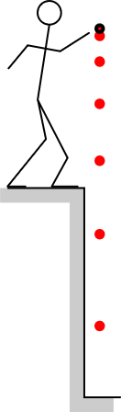 | 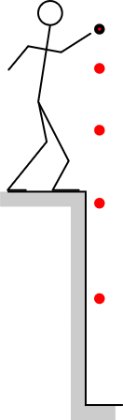 | 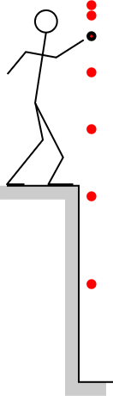
Ball is dropped from rest. | Ball is thrown  straight downward | Ball is thrown  straight upward
v₀ is zero | v₀ is downward | v₀ is upward

Straight line motion occurs when:
- the initial velocity is zero and the acceleration is not zero as illustrated in the first picture. Notice that the black initial dot and the next red dot are very close together.
- the initial velocity and the acceleration have the same direction as illustrated in the second picture. The biggest difference between the first and second picture is that the distance between the black and first red dots in the second picture is bigger than in the first picture.
- the initial velocity and the acceleration have opposite directions as illustrated in the third picture. This case is easy to identify because the black dot does not lie at one end of the string of dots. The direction of the initial velocity is toward the location where the ball turns around.

The fourth way that a y vs x graph can be straight is if the object has a non-zero initial velocity while the acceleration is zero. The string of red data points in this case will be uniformly spaced. The direction of the initial velocity will be the direction in which the red data points stretch.

Be aware that in the rocket simulation, the string of data points in not likely to form a vertical straight line because the rocket is moving under the influence a thrust force which likely will not be directed downward as was the case with the examples above.

How do you determine the direction of the acceleration? (when v₀ and a have different directions and v₀ is not zero)
Imagine watching a friend throw a ball to another friend as shown in the diagram below. Because of gravity, the ball doesn’t follow a straight line. In fact, if the drag from air can be ignored, then the ball follows a path that is shaped like a parabola. This parabolic path is called the ‘trajectory’ of the ball.

Now compare the trajectory in the diagram above to the y vs x graph for the same ball that is shown below.

They appear to be identical because they are. Both represent a plot of the vertical coordinate y vs the horizontal coordinate x of the ball. In short, a y vs x graph of a motion is identical to the trajectory in a photograph of that motion.

The acceleration in the ball-throwing example above is constant and is the earth’s freefall acceleration. Its direction is straight down. All of the accelerations in this simulation are also constant so result in parabolically shaped trajectories. The direction of such accelerations will always be in the direction that the parabola opens.

One difficulty that you will likely encounter is that the y vs x graphs that you see may only show a portion of a parabola, not the entire parabola. The portion that is displayed may not even include the vertex of the parabola. In such cases, it is more difficult to determine the exact direction in which the parabola opens. Keep in mind, however that the component of the velocity perpendicular to the acceleration will be constant. For example, if the acceleration points vertically, then the horizontal spacing between the data points will be uniform. If the acceleration points diagonally, then the data points will be spaced uniformly in the direction of the opposite diagonal. Hence, if it is difficult to determine the direction in which the parabola opens, try to determine the direction in which the data points are uniformly spaced.

How do you determine the direction of the acceleration? (when the motion is linear.)
To state the obvious, horizontal position is plotted on the horizontal axis of a y vs x graph and vertical position is plotted on the vertical axis. This is no different than what would be ‘plotted’ if it were possible to take a photograph of a moving object’s path or trajectory.

Notice that the first part of the y vs x graph for the current problem is a straight line. There are four possible ways this can happen. The diagrams below illustrate three of the four ways. All three examples involve a ball’s motion near the earth, because the freefall acceleration from the earth is constant just as the acceleration is constant for the motions in this simulation. Notice that in all three examples, the distance between the data points increases as the ball falls. In each picture, the initial location of the ball is illustrated by the black data point.

Ball is dropped from rest. | Ball is thrown  straight downward | Ball is thrown  straight upward
v₀ is zero | v₀ is downward | v₀ is upward

The ball’s path or trajectory is straight in all three cases because the initial velocity is either zero or has a direction that is either that same or opposite to the acceleration. In all three cases, however, the direction of the acceleration is the same as the direction in which the ball is speeding up.

Likely, a straight-line y vs x graph in this simulation will not be vertical. Still, however, the direction of the acceleration for such a graph will be in along that straight line and in the same direction the object is speeding up.

The fourth way in which a y vs x graph might be straight is if the acceleration is zero but the initial velocity is not. Such straight lines are easy to distinguish from the examples illustrated above because the data points will be uniformly spaced. Uniformly spaced straight line data points do indeed correspond to zero acceleration because the velocity is not changing either in magnitude or in direction.

