x vs. t and y vs. t Graphs
The problem you are currently viewing involves x vs. t and y vs. t graphs. Hence, all of the help below relates to those types of graphs as well.

How do you determine the direction of the initial velocity from x vs. t and y vs. t graphs?

An x vs t graph describes the horizontal component of a motion only. No information about the vertical component of a motion can be gleaned from an x vs. t graph. The opposite is true for a y vs. t graph. No information about the horizontal component of a motion can be gleaned from a y vs. t graph.

Both x vs. t and y vs. t graphs are position vs. time graphs. The same rules that describe how to read information from one type of graph apply to the other type of graph as well. The paragraph below refers to an x vs. t graph but could just as easily refer to a y vs. t graph.

On an x vs. t graph, the slope of the curve at a given instant is equal to the x-component of the velocity of the object at that instant (i.e., v_{x}). Positive slopes correspond to positive values of the x component of the velocity (i.e., v_{x} > 0). Negative slopes correspond to v_{x} < 0. A zero slope corresponds to v_{x} = 0. The x-component of the initial velocity, v_{ox}, is determined by the slope of the curve at t=0s. In the simulation, the t=0s data point is marked by a thick black border.

Hence, to determine the sign of v_{ox}, determine the slope of the x vs. t graph at t=0s. Similarly, to determine the sign of v_{oy}, determine the slope of the y vs. t graph at t=0s.

The initial velocity selector is a plot of v_{oy} vs. v_{ox}. Hence, knowing the signs of both v_{ox} and v_{oy} is sufficient to correctly select the direction of the initial velocity with the selector.

How do you determine the direction of the acceleration?
An x vs t graph describes the horizontal component of a motion only. No information about the vertical component of a motion can be gleaned from an x vs. t graph. The opposite is true for a y vs. t graph. No information about the horizontal component of a motion can be gleaned from a y vs. t graph.

Both x vs. t and y vs. t graphs are position vs. time graphs. The same rules that describe how to read information from one type of graph apply to the other type of graph as well. The paragraph below refers to an x vs. t graph but could just as easily refer to a y vs. t graph.

On an x vs t graph, the slope represents the x-component of the velocity (i.e., v_{x}). This implies that the sign of the slope determines the sign of v_{x} and the steepness of the slope determines the magnitude of v_{x}. A steep slope corresponds to an object that is moving fast and a flat slope to an object that is moving slow.

Consider an object that is moving along the x-axis. When it is speeding up, the x-components of its velocity and acceleration have the same sign. When it is slowing down, the signs of the x-components of its velocity and acceleration are opposite. When it moves at constant velocity, then the x-component of its acceleration is zero

The rules described above are applied to each of the graphs below to determine the x-component of the acceleration of each.

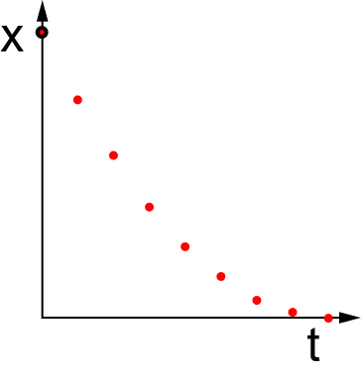 | 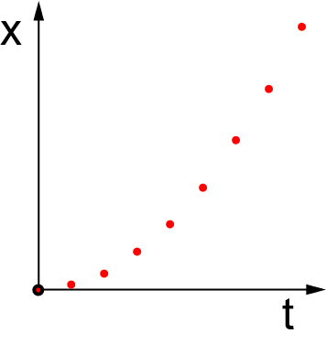 | 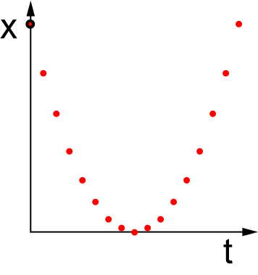
slope < 0 ⇒ v_{x} < 0  steep to flat slope ⇒ slowing down  v_{x} <0 & slowing down ⇒ a_{x} > 0 | slope > 0 ⇒ v_{x} > 0  flat to steep slope ⇒ speeding up  v_{x} > 0 & speeding up ⇒ a_{x} > 0 | This graph is a combination  of the first two graphs  ⇒ a_{x} > 0

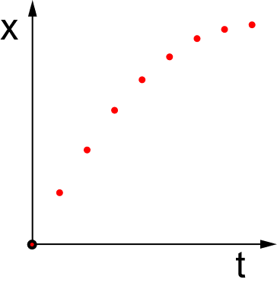 | 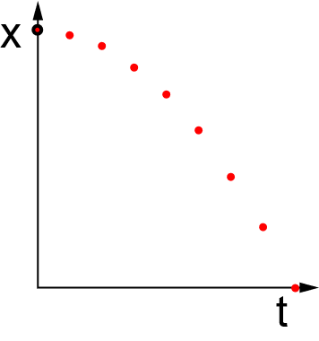 | 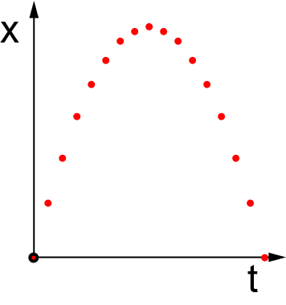
slope > 0 ⇒ v_{x} > 0  steep to flat slope ⇒ slowing down  v_{x} >0 & slowing down ⇒ a_{x} < 0 | slope < 0 ⇒ v_{x} < 0  flat to steep slope ⇒ speeding up  v_{x} < 0 & speeding up ⇒ a_{x} < 0 | This graph is a combination  of the first two graphs  ⇒ a_{x} < 0

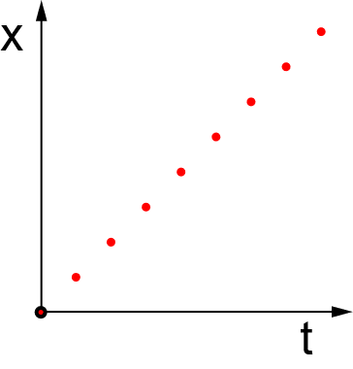 | 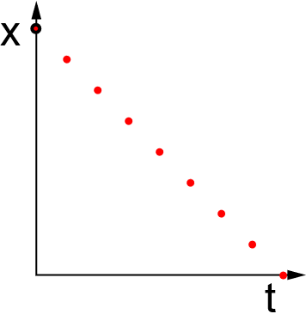 | 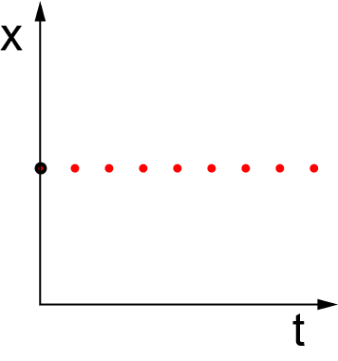
constant slope ⇒ constant speed  constant speed ⇒ a_{x} = 0 | constant slope ⇒ constant speed  constant speed ⇒ a_{x} = 0 | constant slope ⇒ constant speed  constant speed ⇒ a_{x} = 0

Notice that the three graphs in the top row all have an a_{x} that is positive. In addition, notice that the graphs in the top row have a shape that is part or all of a ‘smiley face’. The graphs in the middle row that have negative a_{x} all have a shape that is part or all of a ‘frowny face’. The graphs in the bottom row that all have zero a_{x} are all straight graphs. Hence, the following relationships give a quick way for determining the sign of a_{x} for x vs. t graphs:
- An x vs. t graph that is curved like a smiley face has a positive a_{x}.
- An x vs. t graph that is curved like a frowny face has a negative a_{x}.
- An x vs. t graph that is straight has a zero a_{x}.
The same relationships between the shape of y vs. t graphs and the signs of their a_{y}.

The acceleration selector is a graph of a_{y} vs. a_{x}. The selector only has one choice for the magnitude of the acceleration in each direction. Hence, knowing the signs of a_{x} and a_{y} is sufficient for selecting the correct acceleration.

