How do you determine the direction of the initial velocity from a y vs x graph?

Imagine watching a friend throw a ball to another friend as shown in the diagram below. Because of gravity, the ball doesn’t follow a straight line. In fact, if the drag force from air can be ignored, then the ball follows a path that is shaped like a parabola. This parabolic path is called the ‘trajectory’ of the ball.

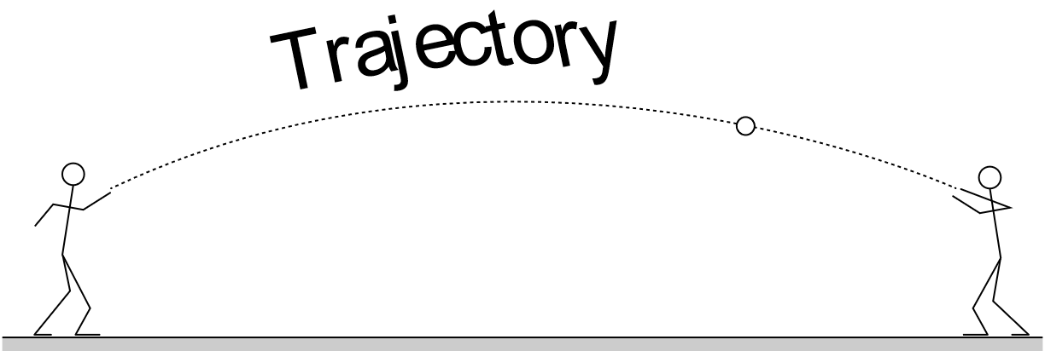

Now compare the trajectory in the diagram above to the y vs x graph for the same ball that is shown below.

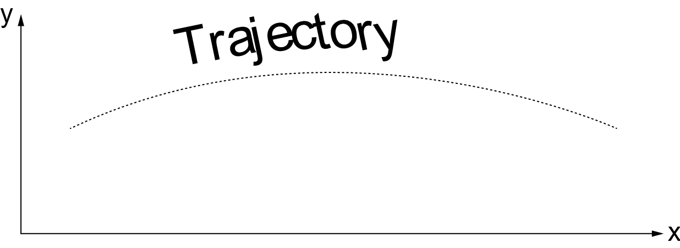

They appear to be identical because they are. Both represent a plot of the vertical coordinate y vs the horizontal coordinate x of the ball. In short, a y vs x graph of a motion is identical to the trajectory in a photograph of that motion.

The diagram below is identical to the one above, but this time, the ball is shown at five different instants as it moves along its trajectory. A velocity vector has also been drawn at each of these five instants. The directions of these velocity vectors indicate the direction the ball is moving at each instant. Notice that each of the velocity vector is tangent to the trajectory.

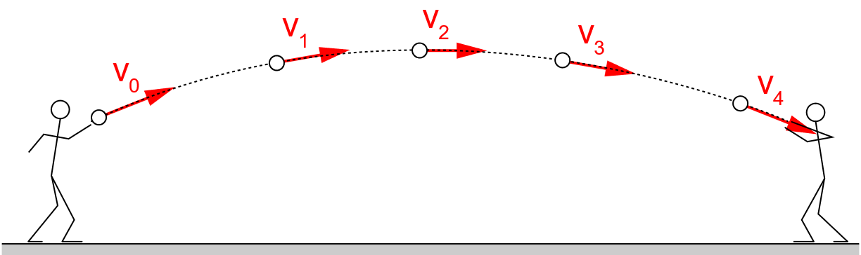

The reason you chose to read this blurb of text is to answer the question:
‘How do you determine the direction of the initial velocity?’

The initial velocity has the same direction as the vector that is tangent to the trajectory at the initial location of the ball! In the diagram above, the initial location is the instant the ball leaves the person’s hand. Hence, the vector labeled ‘v₀’ in the diagram is the initial velocity. In the simulation, the initial location is indicated by the data point that has a black border and is slightly larger than the other data points. Hence, to determine the direction of the initial velocity, simply determine the direction that is tangent to the trajectory at that point.

