How do you determine the direction of the acceleration?

To state the obvious, horizontal position is plotted on the horizontal axis of a y vs x graph and vertical position is plotted on the vertical axis. This is no different than what would be ‘plotted’ if it were possible to take a photograph of a moving object’s path or trajectory.

Notice that the y vs x graph for the current problem is a straight line. There are four possible ways this can happen. The diagrams below illustrate three of the four ways. All three examples involve a ball’s motion near the earth, because the freefall acceleration from the earth is constant just as the acceleration is constant for the motions in this simulation. Notice that in all three examples, the distance between the data points increases as the ball falls. In each picture, the initial location of the ball is illustrated by the black data point.

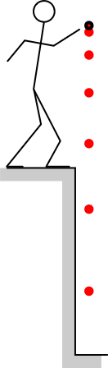 | 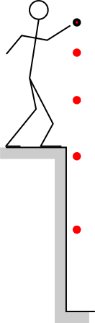 | 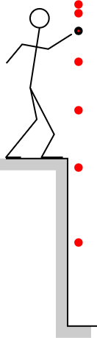
Ball is dropped from rest. | Ball is thrown  straight downward | Ball is thrown  straight upward
v₀ is zero | v₀ is downward | v₀ is upward

The ball’s path or trajectory is straight in all three cases because the initial velocity is either zero or has a direction that is either that same or opposite to the acceleration. In all three cases, however, the direction of the acceleration is the same as the direction in which the ball is speeding up.

Likely, a straight-line y vs x graph in this simulation will not be vertical. Still, however, the direction of the acceleration for such a graph will be in along that straight line and in the same direction the object is speeding up.

The fourth way in which a y vs x graph might be straight is if the acceleration is zero but the initial velocity is not. Such straight lines are easy to distinguish from the examples illustrated above because the data points will be uniformly spaced. Uniformly spaced straight line data points do indeed correspond to zero acceleration because the velocity is not changing either in magnitude or in direction.

