How do you determine the direction of the acceleration?

Imagine watching a friend throw a ball to another friend as shown in the diagram below. Because of gravity, the ball doesn’t follow a straight line. In fact, if the drag from air can be ignored, then the ball follows a path that is shaped like a parabola. This parabolic path is called the ‘trajectory’ of the ball.

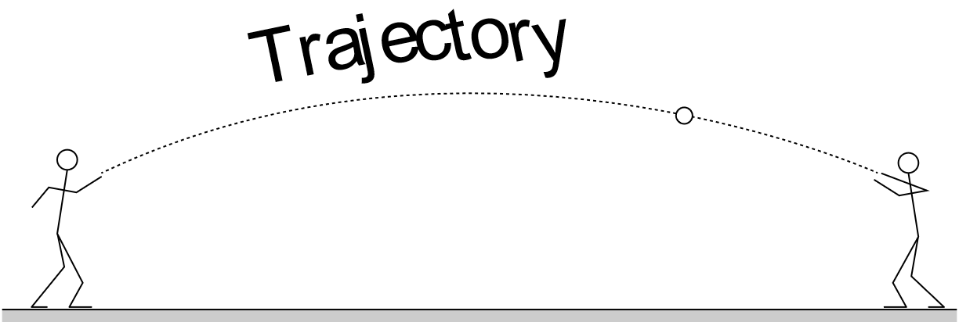

Now compare the trajectory in the diagram above to the y vs x graph for the same ball that is shown below.

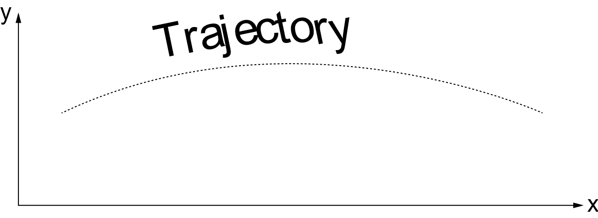

They appear to be identical because they are. Both represent a plot of the vertical coordinate y vs the horizontal coordinate x of the ball. In short, a y vs x graph of a motion is identical to the trajectory in a photograph of that motion.

The acceleration in the ball-throwing example above is constant and is the earth’s freefall acceleration. Its direction is straight down. All of the accelerations in this simulation are also constant so result in parabolically shaped trajectories. The direction of such accelerations will always be in the direction that the parabola opens.

One difficulty that you will likely encounter is that the y vs x graphs that you see may only show a portion of a parabola, not the entire parabola. The portion that is displayed may not even include the vertex of the parabola. In such cases, it is more difficult to determine the exact direction in which the parabola opens. Keep in mind, however that the component of the velocity perpendicular to the acceleration will be constant. For example, if the acceleration points vertically, then the horizontal spacing between the data points will be uniform. If the acceleration points diagonally, then the data points will be spaced uniformly in the direction of the opposite diagonal. Hence, if it is difficult to determine the direction in which the parabola opens, try to determine the direction in which the data points are uniformly spaced.

