Proposed Feedback for freebody diagram on object A
Error | Action by Simulation | Proposed Feedback | Done
FBD includes force on an object other than A  (e.g. on B) | Incorrect force and label are highlighted | The label on the highlighted force indicates that it is acting ‘on’ object B. However, the highlighted force is attached to object A which means that it is acting ‘on’ A. Both cannot be true. Fix this! | X
Missing weight force on object A | Highlight object CM that is missing weight force | The earth exerts a non-contact weight force on every object that is near its surface. Your freebody diagram for object A does not include a weight force.
Weight force in the wrong direction | Highlight weight force | Your freebody diagram of object A includes a weight force that is directed upward. Weight forces are always directed downward toward the center of the earth. Redraw the weight force by object B on A so that it points straight downward. | X
Missing force  (suppose missing force is by B and no other force on FBD is by B) | Highlight ‘B’ object in list of objects touching A. | In the ‘List of Touching Objects’ list, you indicated that object B is touching object A. However, your freebody diagram for object A does not include a force by B. Fix this!
Missing friction force if normal force is present  (e.g., a normal force by object B) | Highlight normal force by B on A | Your freebody diagram for object A includes a normal force by object B. This means that object B is pushing on object A. However, object B is doing more than just pushing on object A. B is also either rubbing against or pulling on object A. Which?  Add the appropriate force to your freebody diagram of object A.
Missing normal force if friction force is present  (e.g., a friction force by object B) | Highlight friction force by B on A | Your freebody diagram for object A includes a friction force by object B. This means that object B is rubbing against object A. However, object B is doing more than just rubbing against object A. B is also either pushing or pulling on object A. Which?  Add the appropriate force to your freebody diagram of object A.

A contact force by an object that is not touching object A  (e.g., B exerts a normal force on A even though B isn’t touching A) | Highlight extra force | Your freebody diagram for object A includes a normal force by B on A. A normal force is a type of contact force. It only exists when object B is actually touching object A. If object B was touching A in the past, then the contact force was present at that time. The instant the contact between A and B is broken, however, the contact force disappears.  Object B is not touching object A at the current instant in this problem. Hence, the normal force by B on A should not be present in your diagram. Remove it! | X

Normal force is opposite to the correct direction  (e.g., a normal force by object B points down when it should be up) | Highlight normal force by object B on A | Your freebody diagram of object A includes a normal force by object B. According to this force, object B is pushing object A downward. Notice, however, that object B is touching the bottom of object A.  Consider the diagram of a block below:  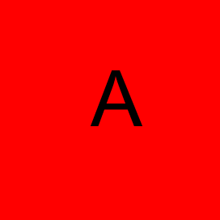  Suppose you push against the bottom of this block. In what direction are you pushing?  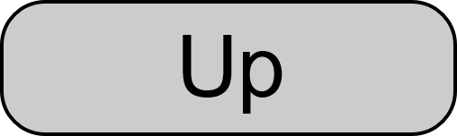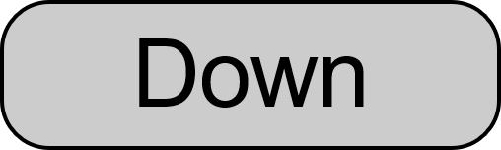  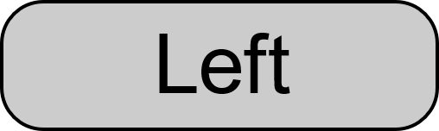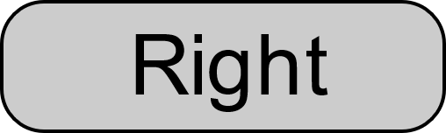  (Indicate whether button presses are correct or incorrect. If needed, repeat for other sides of box A)  Remember that B is touching the bottom of block A. In which direction is the normal force by B on A? Fix this direction in your freebody diagram. | X
Normal force is not perpendicular to surface (e.g., a normal force by object B) | Highlight normal force by object B on A.  Also in the picture of the objects, highlight the surface between objects A and B. | Your freebody diagram of object A includes a normal force by object B. According to your diagram, this normal force is directed up and to the right.  The word ‘normal’ literally means ‘perpendicular’. A normal force is called ‘normal’ because it is always perpendicular to the surface where that force is exerted. That surface is highlighted in the picture of the objects.  Redraw your normal force by B on A so that it is perpendicular to the highlighted surface. | X

Tension force is not parallel to string that causes it.  (e.g., a tension force by string B) | Highlight tension force by object B on A  Also highlight string in the picture of objects | Your freebody diagram of object A includes a tension force by object B on A. According to that diagram, the direction of this tension force is up and to the right.  Tension forces caused by strings are always parallel to the string. In this case, the tension force by B on A should be parallel to the string that is highlighted in the picture above.  Redraw the tension force by B on A so it is parallel to this string. | X
Tension force directed so that string that causes it would collapse, not remain taut. | Highlight tension force by object B on A  Also highlight string in the picture of objects | Your freebody diagram of object A includes a tension force by object B on A. According to that diagram, the direction of this tension force is up and to the right.  Strings pull, they do not push. If you attempt to push with a string, the string simply goes limp. The direction of the highlighted tension force in your freebody diagram of object A implies that the string is pushing, not pulling. This is not possible.  Redraw the tension force by B on A so it is consistent with a string that is pulling. | X

Friction force is in the opposite of the correct direction (e.g., friction by object B is to the left when it should be to the right). | Highlight friction force by B on A | Your freebody diagram of object A includes a friction force by object B on A. Your diagram indicates that the direction of this friction force is to the left.  According to the problem description, object A is sliding to the left against object B. The direction of the friction force on object A should be opposite to the direction object A slides relative to object B. If object A has moving parts, then the direction of the friction force on A is opposite to the direction that the part of object A that is rubbing against object B is moving relative to B.  Since object A is sliding to the left, what is the correct direction of the friction force by B on A? | X
Friction force is not parallel to the surface on which A is sliding | Highlight friction force by B on A  Also highlight the surface on which object A is sliding | Your freebody diagram of object A includes a friction force by object B on A. Your diagram indicates that the direction of this friction force is up and to the left.  Friction forces are always parallel to the surface on which the object is sliding. In this problem, object A is sliding along the surface that is highlighted in the picture above. Redraw the friction force by B on A so that it is parallel to this surface. | X

Half of a third law pair is missing  (e.g., suppose normal by B on A is present but normal by A on B is missing) | Highlight the half of the third law pair that is present | Your freebody diagram of object A includes a normal force by B on A. This implies that B is pushing on A. However, whenever object B pushes on A, object A pushes on B. This means that there must also be a normal force by object A on B. Your diagram for object B does not show this second normal force. Fix it!  (Same feedback for missing friction or tension forces.)
Both pairs of a third law pair are present, but one of the forces is in the wrong direction | Highlight the two halves of the third law pair | Your freebody diagram of object A includes a normal force by B on A. Your freebody diagram of object B includes a normal force by A on B. These two forces have been highlighted in your freebody diagrams.  If object A pushes on object B then B pushes back on A. This implies that the normal forces by B on A and by A on B must be in opposite directions.  The two highlighted normal forces in your freebody diagrams are not in opposite directions. One or both have an incorrect direction. Fix this!

The problem statement indicates that an object is at rest. The forces in the FBD indicate that the object has a non-zero net force. | Highlight the forces in the FBD. | The forces you have drawn in the freebody diagram for object A are unbalanced. According to your freebody diagram, object A has a net force directed to the west. According to the problem statement, however, object A is sitting at rest. An object at rest has a net force of zero.  Either something is wrong with the forces you have already drawn or one or more forces are missing from the freebody diagram for object A.
The forces in a FBD gives a net force direction that differs from the direction of the acceleration in the problem statement | Highlight the forces in the FBD. | The forces you have drawn in the freebody diagram for object A are unbalanced. According to your freebody diagram, object A has a net force directed to the west. According to the problem statement, however, object A is accelerating to the east. The direction of the net force must match the direction of the acceleration.  Either something is wrong with the forces you have already drawn or one or more forces are missing from the freebody diagram for object A.

