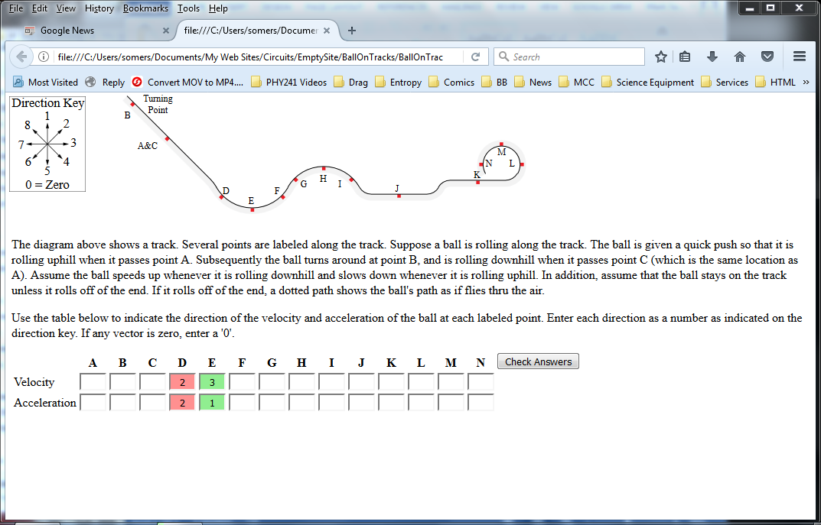

The diagram above is a screenshot of the program in its current state. I entered a few sample answers, then clicked the ‘Check Answers’ button. The program colors the answers to indicate which are correct and which are incorrect.

Preliminary Ideas on a Help System.
I envision designing a ‘Help’ button. When it is clicked, it will focus the user’s attention on the first incorrect velocity. Only after all of the velocities are correct will it focus a user’s attention on an incorrect acceleration.

The table assumes the user’s focus is on the velocity at point D.

Velocity at point D
Student Answer | Feedback
1,2,3,5,6,7 | The velocity at any point along the ball’s trajectory is always tangent to that trajectory. The direction you chose for the velocity at point D is not tangent to the track at point D. Click this link to see examples of vectors that are tangent to a trajectory and other examples that are not.  (Clicking the link will load a web page that shows pictures of a few vectors that are tangent to a curve and a few that are not).
8 | Direction 8 indicates that when the ball is at point D, it is rolling toward point C, not toward point E.
After all of the velocity directions are correct, focus the user on an incorrect acceleration, perhaps the acceleration at point D:

Acceleration at point D
Student Answer | Feedback
1 | The angle between the directions of your velocity and acceleration is obtuse. This indicates that the ball is slowing down. Is it?
2 | The angle between the directions of your velocity and acceleration is 90°. This indicates that the ball is turning but isn’t speeding up or slowing down. Is this true?
3 | Correct answer.
4 | If the acceleration is in direction 4, then the directions of the velocity and acceleration are the same.  Remember that average acceleration is defined as $\vec{a}= \frac{Δ\vec{v}}{Δt}$.  Remember that the direction of the acceleration is the same as the direction of the change in velocity. Finally, remember that a velocity can change in two different ways:  - The magnitude of the velocity can change (i.e., the object can speed up or slow down).  - The direction of the velocity can change (i.e., the object can turn).  If the velocity and acceleration point in the same direction, then the magnitude of the velocity changes, but not its direction. Is it true that the ball is moving in a straight line at point D?  Alternative Feedback (i.e., a version that is shorter).  If the acceleration is in direction 4, then the directions of the velocity and acceleration are the same. An object that has a velocity and acceleration in the same direction moves in a straight line, not a curve. Is the object moving in a straight line?
5,6,7 | Remember that average acceleration is defined as: $\vec{a}= \frac{Δ\vec{v}}{Δt}$.  Remember that the direction of the acceleration is the same as the direction of the change in velocity. The change in velocity is defined as: $Δ\vec{v}= \vec{v_{f}}-\vec{v_{o}}$. Put another way, change in velocity is what must be added to the initial velocity to obtains the final velocity: $\vec{v_{f}}=\vec{v_{o}}+Δ\vec{v}$.  You said that the direction of the acceleration is (5, 6 or 7). That means that the direction of $Δ\vec{v}$ is the same. You also said that the direction of $\vec{v_{o}}$ is 4. Imagine graphically arranging $\vec{v_{o}}$ to $Δ\vec{v}$ head to tail in order to add them to obtain $\vec{v_{f}}$. Does this sum give a final velocity in the correct direction? Must an acceleration be directed toward the interior or the exterior of a curve?
8 | You indicated that the acceleration at point D is opposite in direction to the velocity. When the velocity and acceleration lie on the same straight line, then the ball must be moving in a straight line. Is it?

